# Phase 2 Website Changes & Mock-ups

This is a record of proposed changes to the Glasswall corporate website for Phase 2.

Please send feedback to the slack channel [#gw-website](https://app.slack.com/client/TRQU3V52S/CTHAC26EQ).

Mobile layout changes are in Blue text (mobile).

CTA = Call to action

### How to view the mock-up images:

1. Click the links provided in this document to view the raw image in your browser.

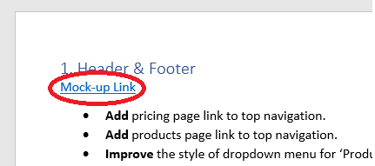

Alternatively, you can find the images on GitHub:

1. Go to [/website mock-ups/phase 2 on GitHub](https://github.com/filetrust/glasswall-marketing/tree/master/Website%20Mockups/Phase%202)
2. Click on a .jpg of a page to review.
3. Use the download button to view the raw image in your browser.

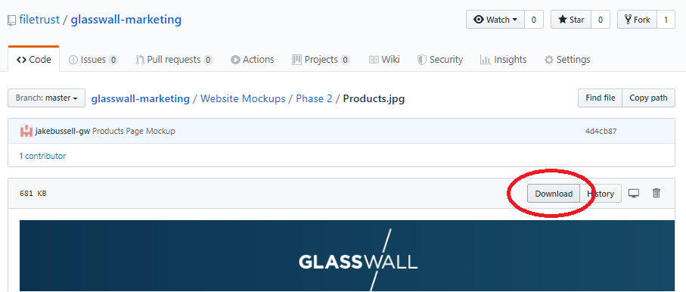

### 1. Header & Footer

[Mock-up Link](https://raw.githubusercontent.com/filetrust/glasswall-marketing/master/Website%20Mockups/Phase%202/Mock-up%20Images/01_Header-and-Footer.jpg)

* **Add** pricing page link to top navigation.
* **Add** products page link to top navigation.
* **Improve** the style of dropdown menu for ‘Products’ for easy navigation.
* **Move** partners page link to under company as a dropdown item, to reduce the amount of links.
* **Add** YouTube and Medium social links to the footer.
* **Add** product categories to footer (these will link to the relevant category in the product page)
* **Add** Pricing to footer under products.

### 2. Front Page

[Mock-up Link](https://raw.githubusercontent.com/filetrust/glasswall-marketing/master/Website%20Mockups/Phase%202/Mock-up%20Images/02_Front-page.jpg)

* **Move** the third main top content block ‘Glasswall offers unparalleled protection...’ into it’s own section. That leads to Glasswall products.
* **Remove** File Trust for email (replaced by ‘Glasswall offers unparalleled protection...’)
* **Improve** text formatting on the top content blocks to me more readable and include padding (mobile).
* **Improve** partners and alliances to display top 9 partners.
* **Improve** partner logos so that they are clickable and lead to a custom link or the partners page.
* **Improve** Testimonials section into a carousel. There are currently three quotes, more testimonials can be added and updated.
* **Rename** ‘Our Latest Resources’ to ‘Latest Resources’.
* **Remove** ‘News articles’ from the resources section and **Replace** it with ‘Tech Blog’ (link to https://medium.com/glasswall-engineering).
* **Improve** featured images in the resources section so they react when hovered and are clickable.
* **Improve** ‘read more’ button style (on the resources section) to match others on site.
* **Remove** free evaluation CTA
* **Add** File Drop ‘Try Our Technology’ CTA

### 3. Technology

[Mock-up Link](https://raw.githubusercontent.com/filetrust/glasswall-marketing/master/Website%20Mockups/Phase%202/Mock-up%20Images/03_Technology.jpg)

* **Add** ‘View products’ button to header.
* **Add** File Drop ‘Try Our Technology’ CTA
* **Remove** Solutions section.
* **Add** products section which leads to the product page.
* **Remove** free evaluation CTA

### 4. Products

[Mock-up Link](https://raw.githubusercontent.com/filetrust/glasswall-marketing/master/Website%20Mockups/Phase%202/Mock-up%20Images/04_Products.jpg)

* **Remove** ‘Solutions’ page. (Set up 101 redirect to /products)
* **Add** new ‘Products’ page to replace ‘Solutions’.
* **Add** new layout that highlights large array of Glasswall products. Scalable and easily editable.

Products have been split into 3 categories:

1. SAAS / SDKs
2. On-Premise / Private Cloud
3. Appliances.

* **Remove** free evaluation CTA.
* **Add** ‘Can’t find what you’re looking for?’ CTA.

### 5. Individual Product pages

[Mock-up Link](https://raw.githubusercontent.com/filetrust/glasswall-marketing/master/Website%20Mockups/Phase%202/Mock-up%20Images/05_Individual-Product-Pages.jpg)

* **Add** new product page layout featuring:

1. Product Intro (25 words)
2. Diagram
3. Use cases
4. Features & Benefits,
5. CTA (product specific) (Also features price point.)
6. Resources (product specific)
7. ‘Need more info?’ CTA

* **Please note:** A product info form will be send to POs when a product is ready to be added to the website. This will provide the content for each product page. POs will fill this out and then messaging will be checked by Nick & Paul. Jake will make design elements such as icons and diagrams for the product. Once okayed from the top, the product will go live on the website.
* **Add** ability to add hyperlinks to product intro in header.
* **Add ‘**visit store’ link in header.
* **Improve** ‘read more’ button style (on the resources section) to match others on site.
* **Add** product overview .pdf in header (same as technology page)

### 6. Pricing

[Mock-up Link](https://raw.githubusercontent.com/filetrust/glasswall-marketing/master/Website%20Mockups/Phase%202/Mock-up%20Images/06_Pricing.jpg)

* **Add** new pricing page added based on the 3-column pricing structure. Page will be easily editable.
* **Add** Function that allows prices to be viewed in GBP (default), or USD. (User clicks on flags in the top right corner to change currency.) Note: Perhaps an easy way to do this would be to have two pages.

### 7. Resources

[Mock-up Link](https://raw.githubusercontent.com/filetrust/glasswall-marketing/master/Website%20Mockups/Phase%202/Mock-up%20Images/07_Resources.jpg)

* **Improve** padding below the top boxes to match the top.
* **Add** grey bar below black area.
* **Change** the layout of the page so thatProduct overviews are now split into 3 categories. When selected, changes to expanded view with .PDFs showing for the corresponding category.
* **Add** anchor points so that links can be made to a certain part of the page.
* **Improve** layout so that categories of datasheets can be expanded to show the .pdfs. This will allow easier navigation of the documents. (mobile)

### 8. File Drop

[Mock-up Link](https://raw.githubusercontent.com/filetrust/glasswall-marketing/master/Website%20Mockups/Phase%202/Mock-up%20Images/08_File-Drop.jpg)

* **Add** buttons below file-drop square: PRODUCT INFO (Link to file-drop product page), VISIT STORE (Link to file-drop store page), CONTACT US (Link to contact page).
* **Improve** Header to be the same height as Glasswall website.
* **Change** background grey to match Glasswall website #fafaf9.

### 9. Partners

[Mock-up Link](https://raw.githubusercontent.com/filetrust/glasswall-marketing/master/Website%20Mockups/Phase%202/Mock-up%20Images/09_partners.jpg)

* **Improve** ‘read more’ button style (on the resources section) to match others on site.
* **Remove** free evaluation CTA
* **Add** File Drop ‘Try Our Technology’ CTA

### 10. Company (People)

[Mock-up Link](https://raw.githubusercontent.com/filetrust/glasswall-marketing/master/Website%20Mockups/Phase%202/Mock-up%20Images/10_Company.jpg)

* **Improve** layout so that bios are hidden by default and can be expanded to show the text. (mobile only)
* **Remove** free evaluation CTA
* **Add** File Drop ‘Try Our Technology’ CTA

### 11. Demo Page

[Mock-up Link](https://raw.githubusercontent.com/filetrust/glasswall-marketing/master/Website%20Mockups/Phase%202/Mock-up%20Images/11_Demo%20Page.jpg)

* **Remove** ‘Free Evaluation’ page (Set up 101 redirect to /demo)
* **Add** new ‘Demo’ page to replace ‘Free Evaluation’ page.

Demo page is now not specific to SAAS.

* **Add** dropdown list to form. Users can select the product they are interested in when submitting a request for a demo. Sales will when know which product a customer wants a demo of and can arrange with POs accordingly.
* **Remove** old SAAS specific icons and info.
* **Add** newfeatured ways of trying our products. New icons, descriptions and links for:

1. File-Drop
2. SDK on GitHub
3. Docker
4. API keys on Swagger (available for free at the store)

### 12. Contact­

[Mock-up Link](https://raw.githubusercontent.com/filetrust/glasswall-marketing/master/Website%20Mockups/Phase%202/Mock-up%20Images/12_Contact.jpg)

* **Improve** layout to be more aesthetic and include visual prompts.
* **Improve** layout on mobile.

### 13. Blogs and Blog posts

* **Remove** free evaluation CTA
* **Add** File Drop ‘Try Our Technology’ CTA